*Annie Williams*

*AT3 | 321541L*

*external task*

Website design and documentation

1. Investigating
2. Devising
3. Producing
4. Word dump
5. Annotated changes
6. Final products
7. Evaluation
8. Surveys
9. Bibliography

*The design process*

*Investigating*

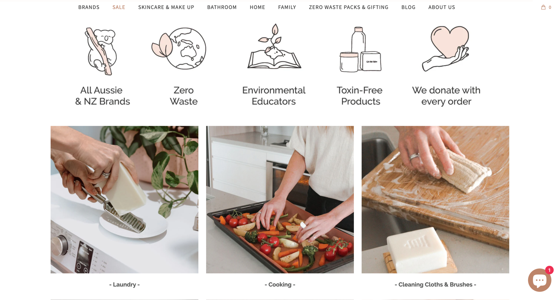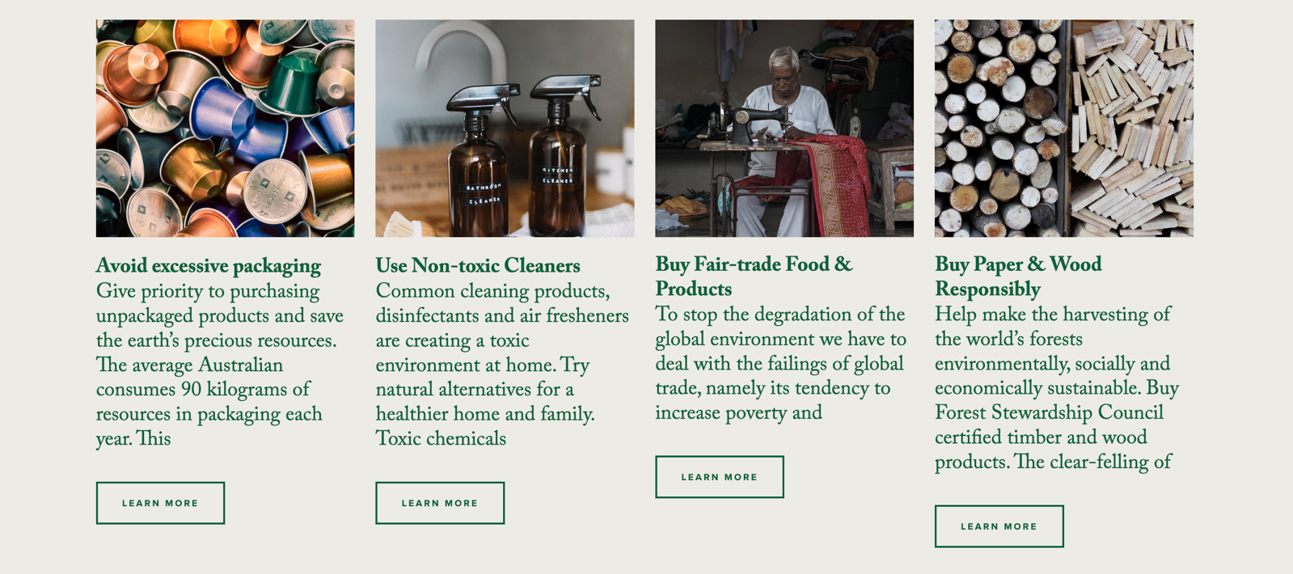

* 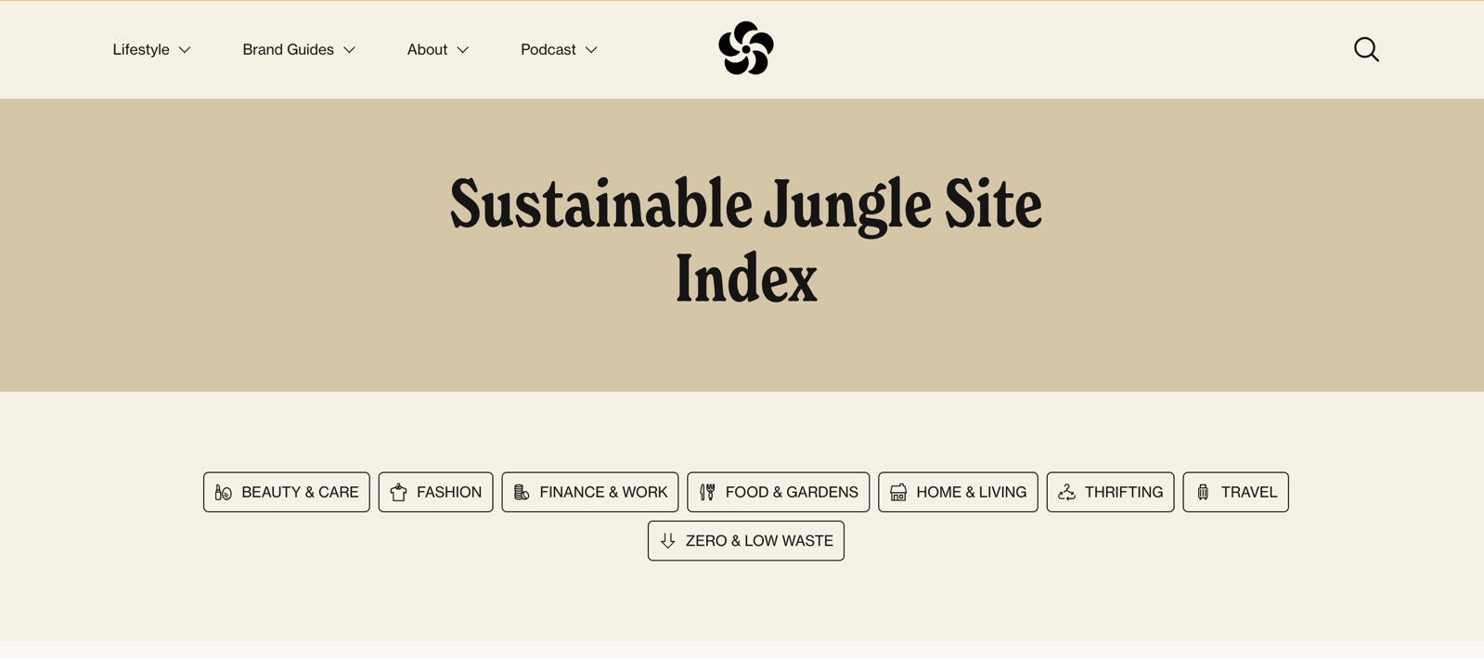After looking at various different website I see common themes such as colours, images and layouts as well as common products and ways of displaying content for this specific genre
* Many of these websites where created in a blog, and whilst these are effective I want to show information in a differentway.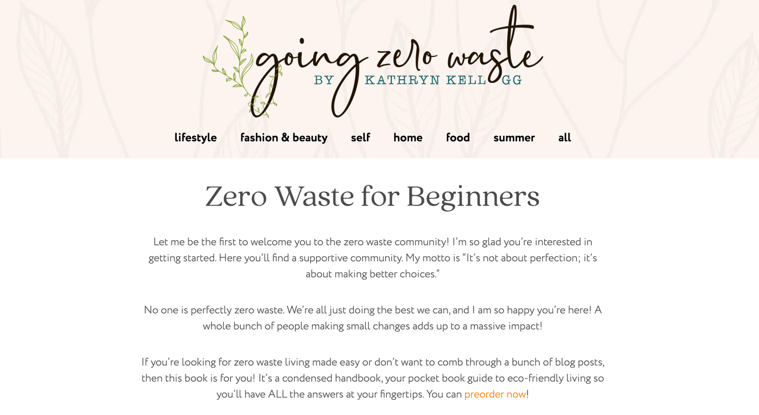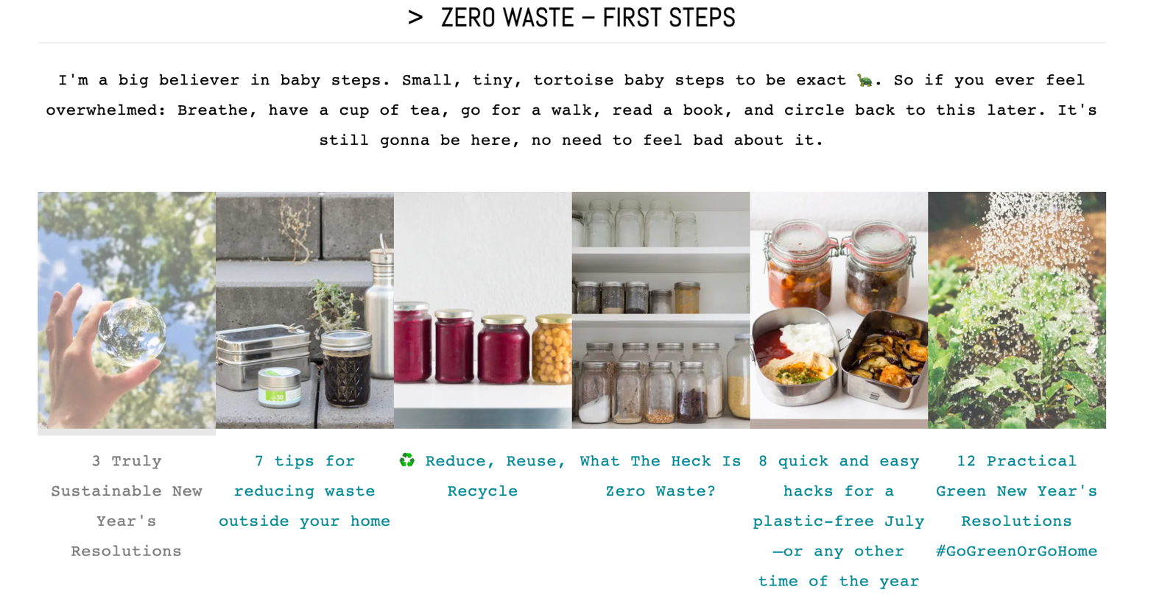

To understand what would work best and create the most interest for me when designing this website, I chose an issue that I am passionate about. From here I used some of my prior knowledge as well as research to find what should be included. I then created the wireframes and started designing the contents of the website.

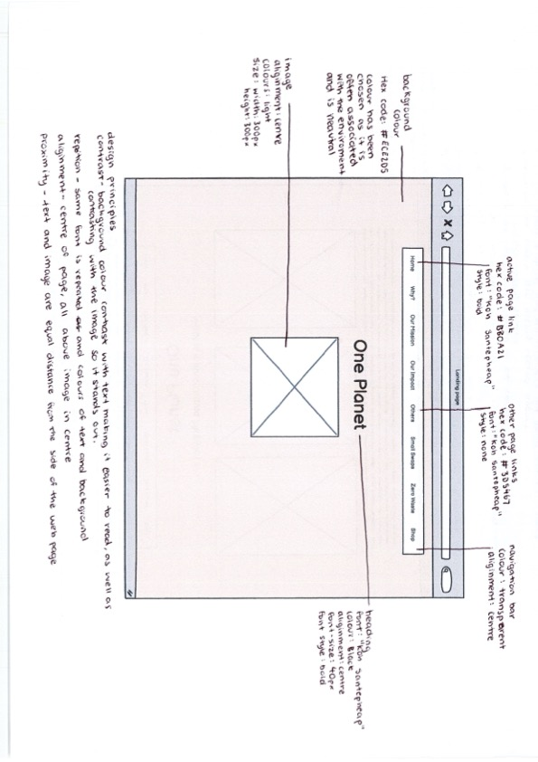Wireframes

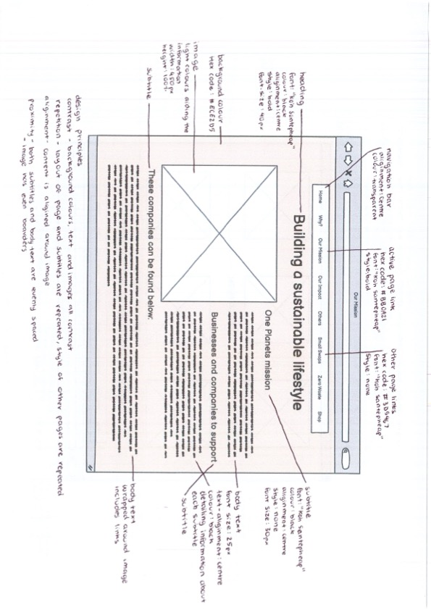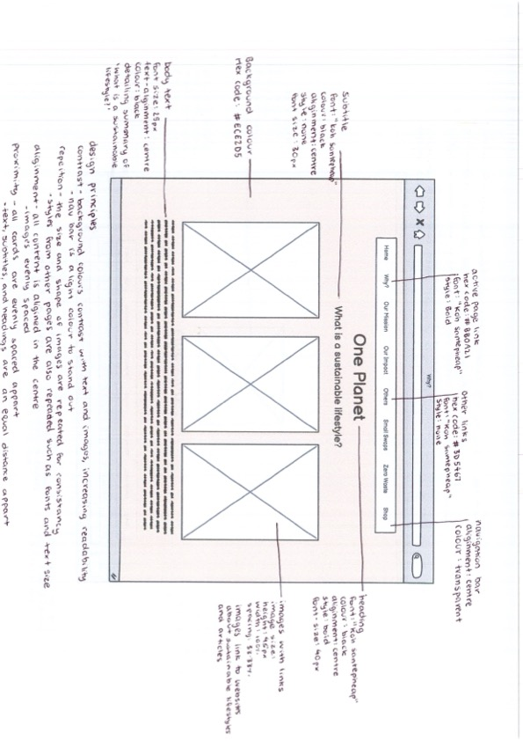

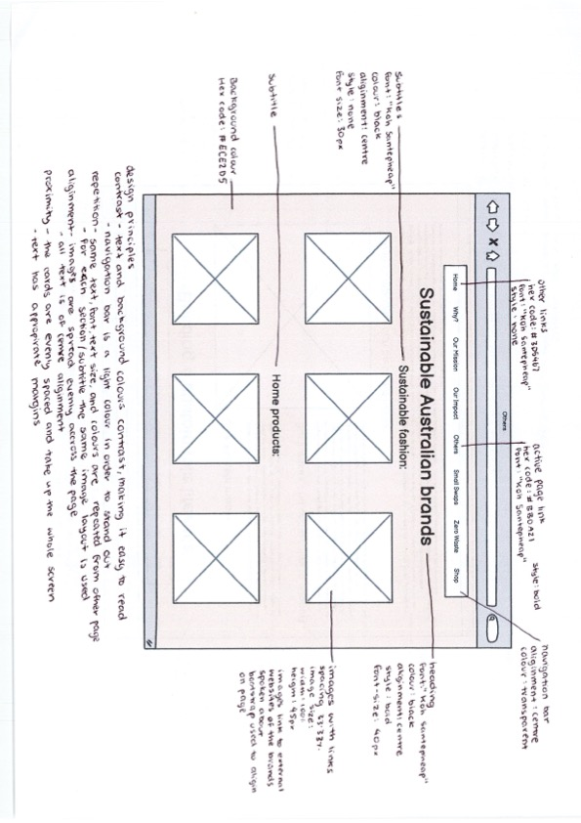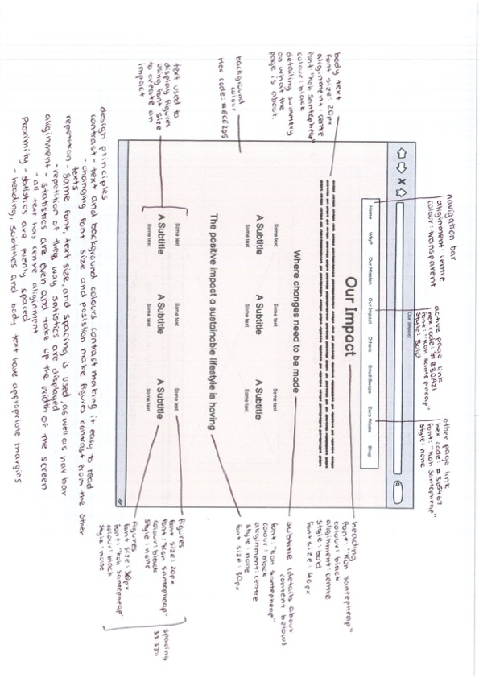

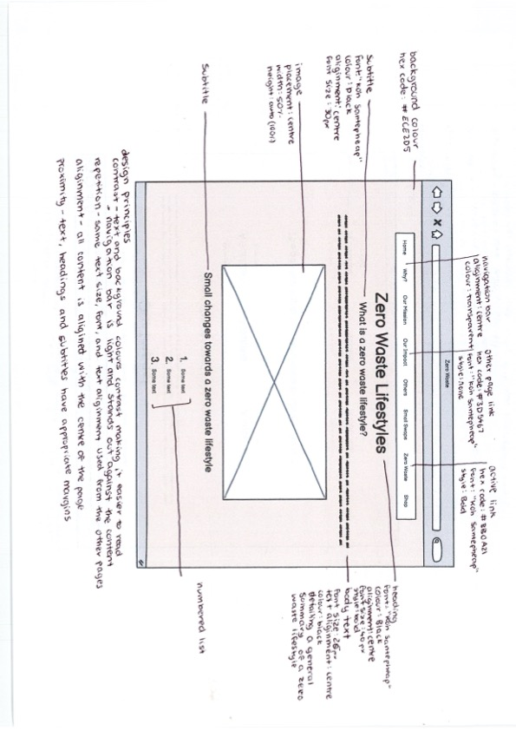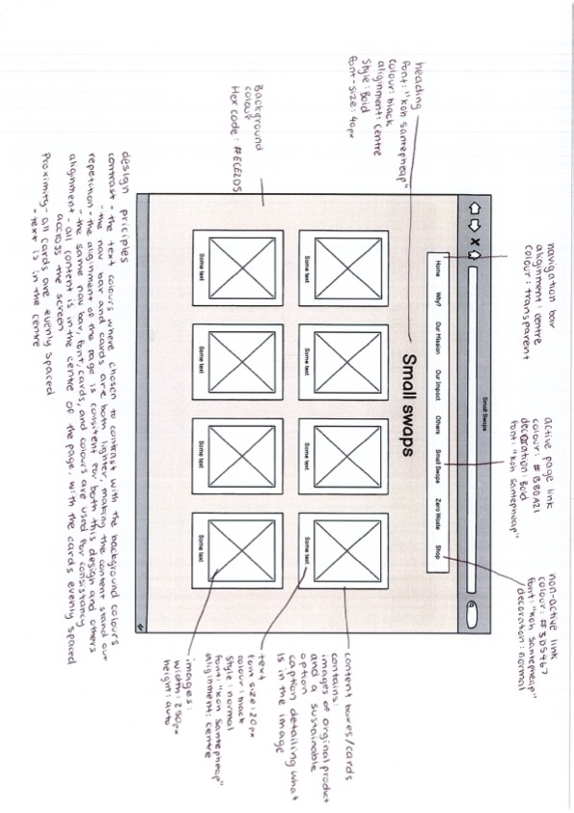

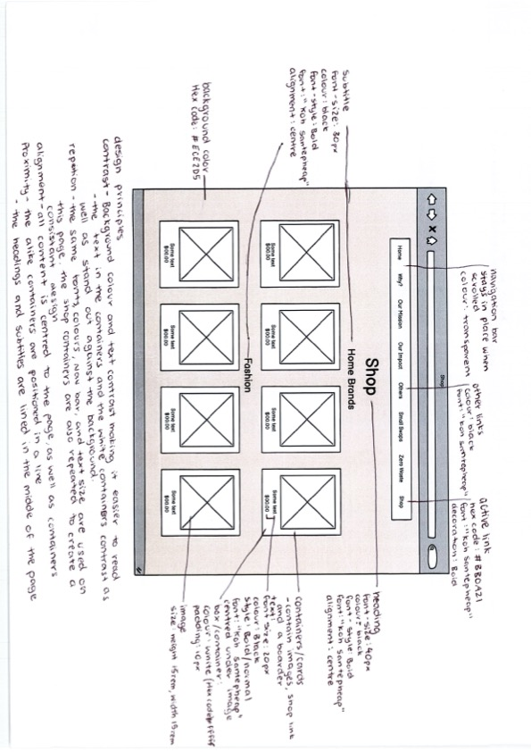

*Devising*

*Investigating summary*

The aim of this task was to create a 6–10-page website about sustainable lifestyles. The webpage must include, long page navigation, a slideshow, video and image lightbox, animation, and all files must be managed as stored effectively. The product produced above is an 8-page website detailing to a younger audience how their small action of living more sustainably helps the planet, whilst also detailing how to do so. The product produced at the end of this assessment is a website that is accessible and appropriately designed. The website is aimed at a younger audience trying to make an impact on the planet. To appeal to this younger audience the page used light and brighter colours. This task was completed in the time frame of week 3 term 3 and week 1 of term 4. To have the website and documentation done within this timeframe internal due dates where created, the website was to be done by week 9 of term 3 and the documentation finished within the holidays. To create this task

*Investigation summary*

The design brief for this task was to create an 8–10-page website under a specific topic, using many stylistic features. The topic of this website is building a sustainable lifestyle, focusing on individuals and how their lifestyles can be altered lower their environmental impact, as well as why it is important to do so. The website is designed for web use on full screen and will consist of 8 pages total. Each page will use a range of stylistic features to showcase the information as shown above in the wireframes. This project is aimed at young adults who are conscious about their environmental impact. The target audience of the website heavily dictated how these pages were designed with the characteristics of the audience being taken into consideration. Many pages have minimal text so the pages can be easily skimmed quickly, and the information is absorbed through other elements such as images, lists, and tables. The target audience was also taken into consideration when choosing colours, as choosing lighter and brighter colours will appeal to younger people. The design choices and audience were taken into consideration as the task was set for 3 months, so the design must be achievable to create within this timeframe. Within the set timeframe, smaller due dates are set to keep the project on track. This includes the wireframes and investigation to be done by the end of the first month and a start to be made on the webpages.

|  |  |  |
| --- | --- | --- |
| Hardware | | |
| Device | Use | Why? |
| MacBook | To create the website, and record all data | This was used to design and produce the website, as the software and programs where on this device. |
| iPhone | To gather and edit images. | The phone was used to edit images for the software installed |
| Software | | |
| Program | Use | Why? |
| Word | For documentation, to record, store progress images, and keep ideas | This program was used as it is accessible and holds all the tools needed to create and document the process. |
| Figma | This software was used to create the wireframes | This program is designed specifically for this use and make designing the pages easy. |
| Sublime Text | This software was used to hold both the html and CSS code. | Sublime text allows all the coding to be accessed in one location and is a program that I was familiar with. |
| GitHub | GitHub was used to create a repository and make the website live. | This allows for any issues to be able to be traced back and the page to be constantly saved as new modifications are made. |

As detailed above within the wireframes the design principles, contrast, repetition, alignment, and proximity (CRAP) are taken into consideration. This CRAP principles are present throughout the pages as it creates a consistent and accessible design. Within the final product these techniques will be used to make a cohesive and well thought out design, which reaches its target audience.

Word count: 481

Repository link:

ZIP folder of website:

*Devising*

Images editing

Site map

*Devising summary*

The website created will be titled ‘One Planet’, insinuating that there is only one planet and we have to work together to save it. This website consists of 8 pages, including a ‘home’ page, this links to many of the pages and creates a general overview of what to expect within the website. ‘Why?’ page, this details both what is a sustainable lifestyle and our impact on the environment, this page is second on the website as it provides and overview on the issues discusses throughout the rest of the pages as well as many external links to articles where readers can gather more knowledge. The next page ‘Our Mission’ speaks of the website ‘One Planet’s aim to help young people build a sustainable lifestyle, detailing the impact and where to find companies which help to achieve this. ‘Our Impact’ page is used to display figures, demonstrating to readers just how harmful many everyday practices are to the environment and how small changes make huge impacts. The following pages ‘others’ and ‘small swaps’ detail products that are better options for both the environment and humans, showing how easy making an impact is. The page ‘zero waste’ details a more extreme type of sustainable lifestyle and the small steps to achieving this. The final page is the 'shop’ tab here all the products mentioned through the website and linked, including prices, and links. The layout, products, pages and images where all taken into consideration when designing to reach the target audience of young adults. Creating pages with small amounts of information to display only important facts allows for the page to be quickly read and understood, with things like colour and images making the website more appealing to read. Each page design was carefully considered for both functionality and the information in which is displays, as shown above in the wireframes the placement of each element allows for the pages to be easily read, and information to be absorbed through the use of design principles such as contrast and alignment. Each page uses the same font sizes, colours, and styles to show a consistent design that is simpler and more allowed the information to stand out.

Word count: 450

*Annotated changes*

Page 1 - Home page

The landing page was done using long page navigation. The use of contrasting colours was evident in the wireframes and used to create eye catching and effective page.

* Pattern
* Balance
  + All carry the same visual weight

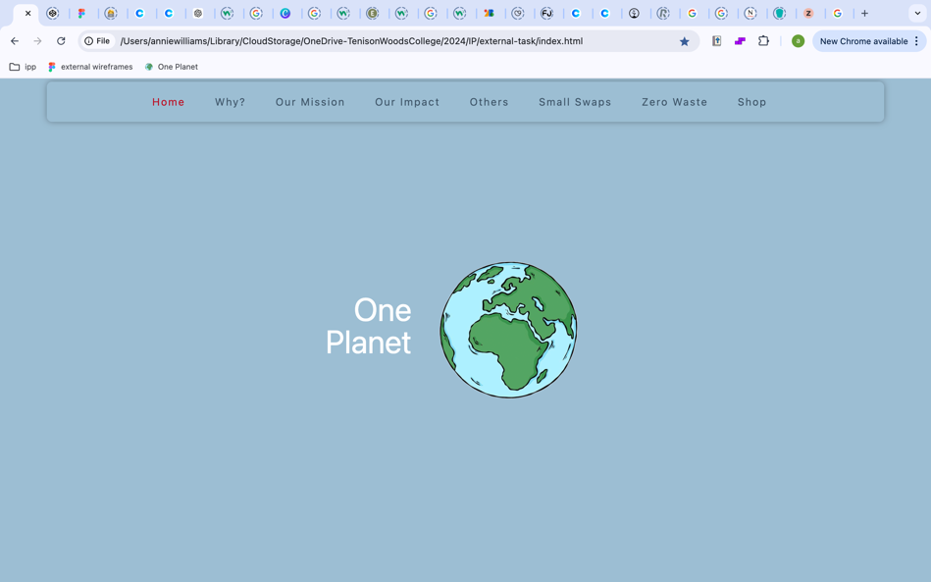The design started out with the incorrect font, and the white did not stand out against the background enough. The image was too small for the size of the page and overall, the first attempt at this page was not what was shown in the wireframes, with the image being beside the text and not below.

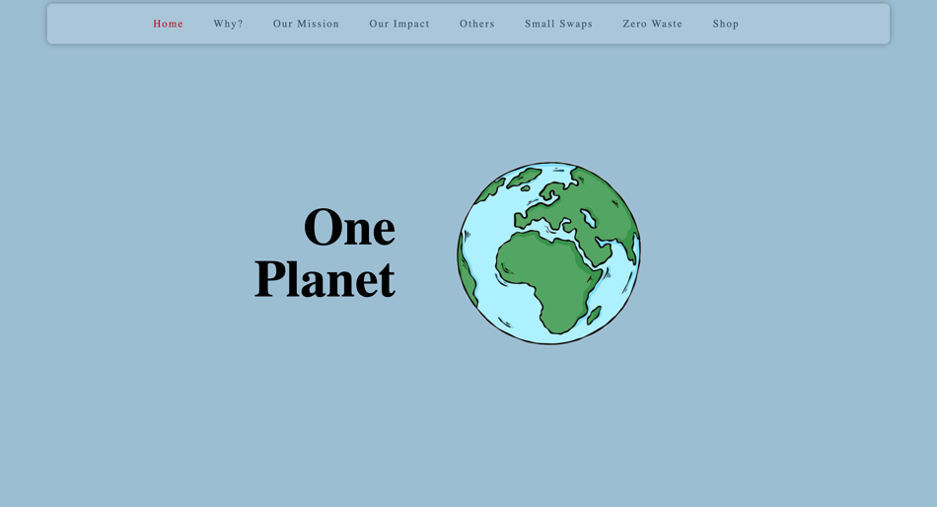

The then altered design displayed the text in a way that was much easier to read and stood out against the background colour. From the wireframes to the final draft of the landing page only the position of the image was changed, as it was better displayed this way.

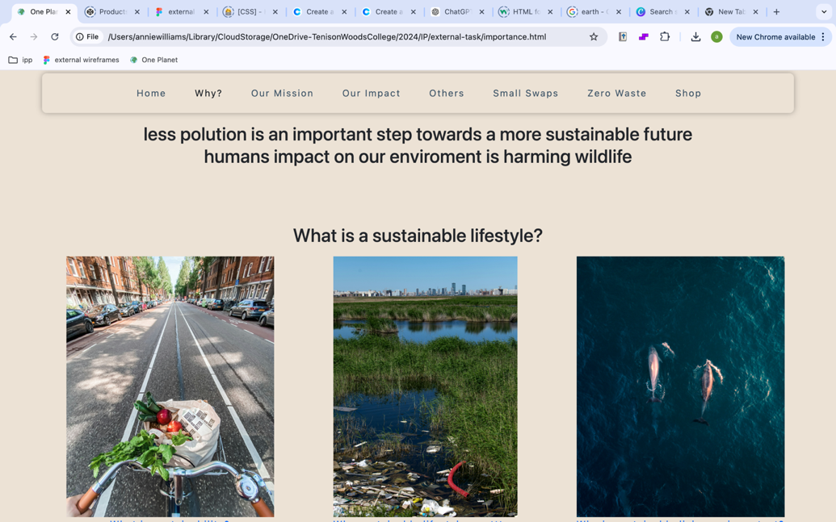

Page 2 - Why?

The first design of this page was very similar to the wireframes, but there were some issues with the images as they were too large to load. The overall layout of the page was functional but could be displayed better.

Design principles used:

* Contrast
* Repetition
* White space

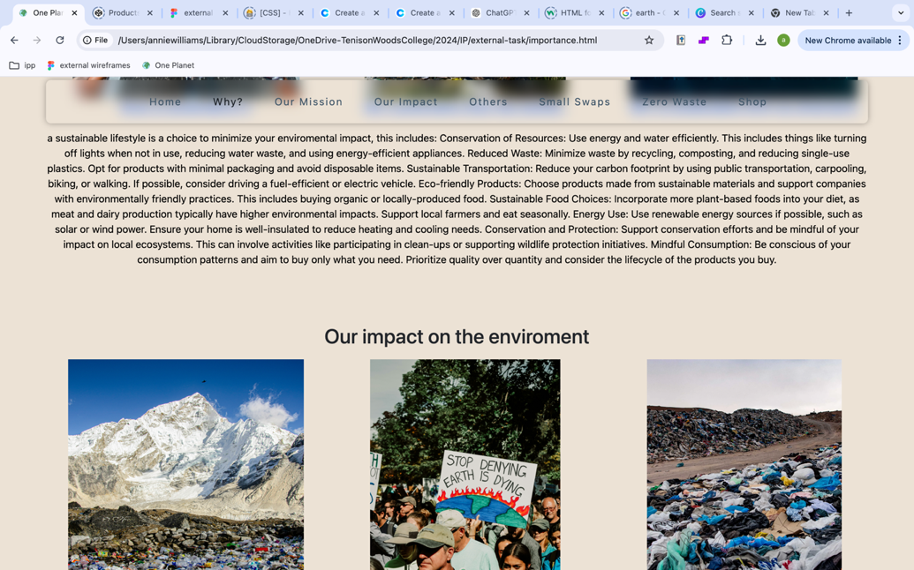

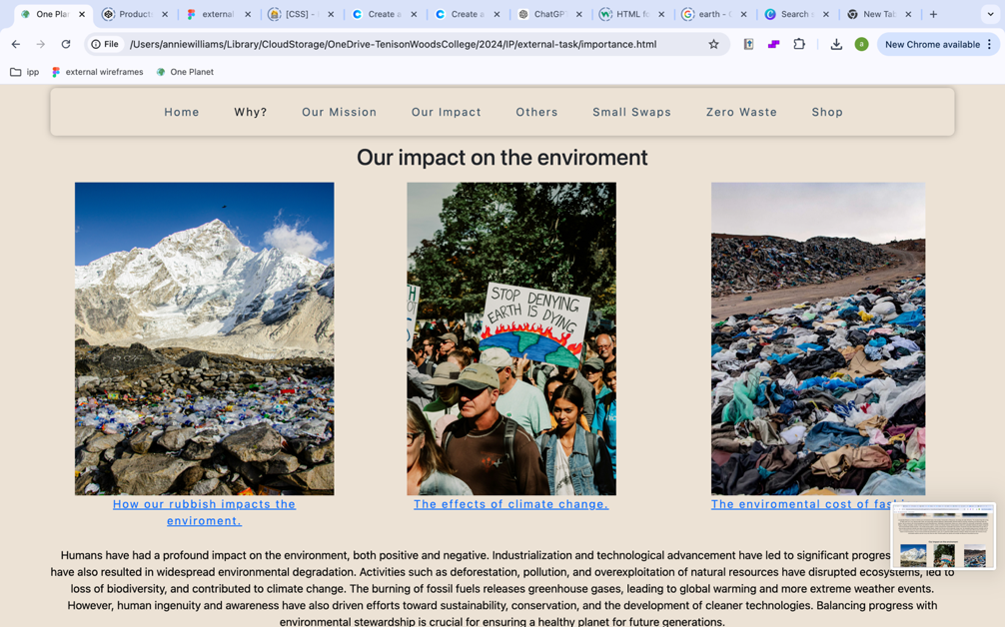

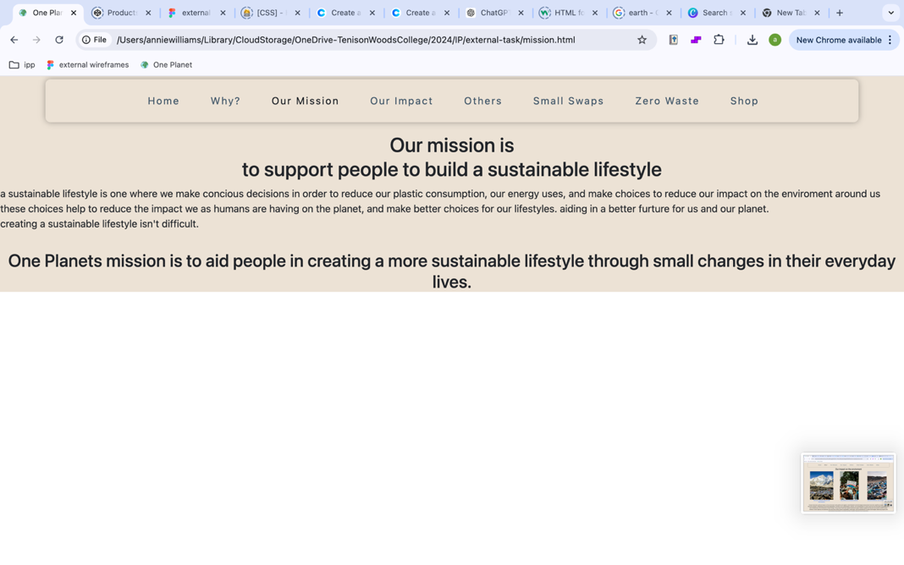Page 3 – Our Mission

This page depicts information about the ‘company’ and the aim of the website. Originally this was small and the text was not displayed in a way that was easy to read and looked nice. This was changed by adding an image and more text to create a fuller looking page.

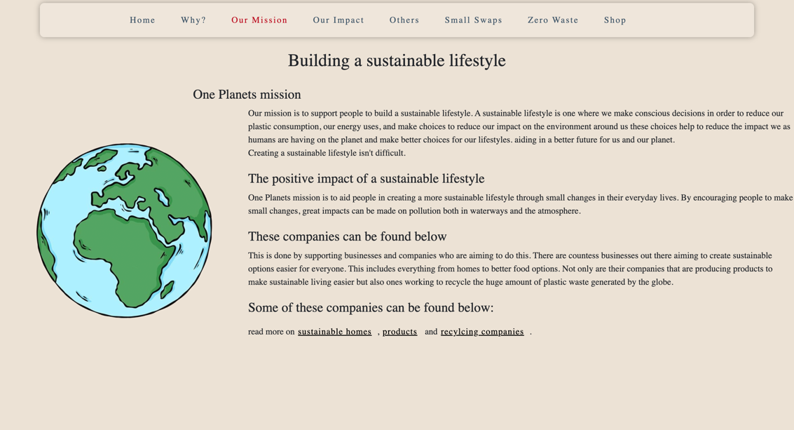On the final page the text surrounds the image and is the correct font and size. This made the page much easier to read and nicer to look at.

Design techniques:

* Typography
* White space

Page 4- Our impact

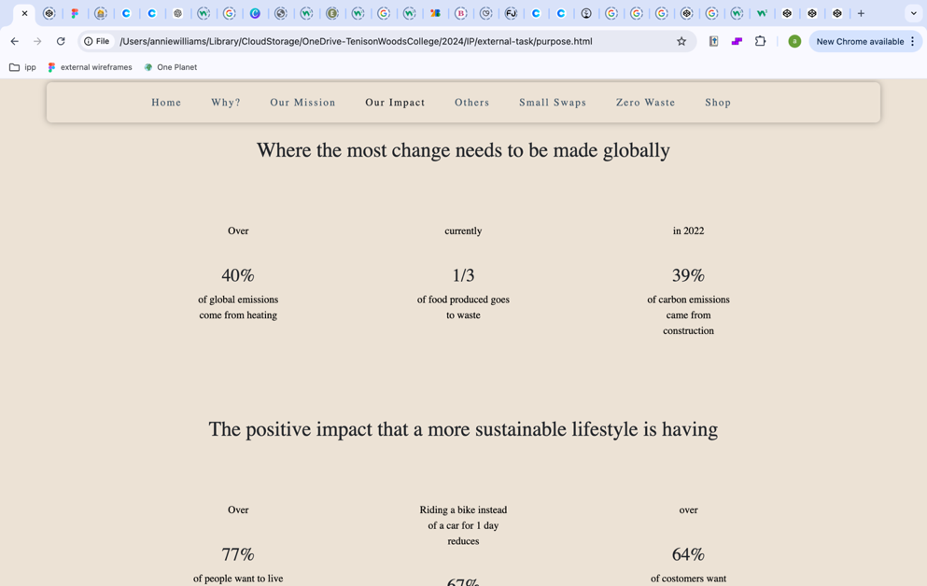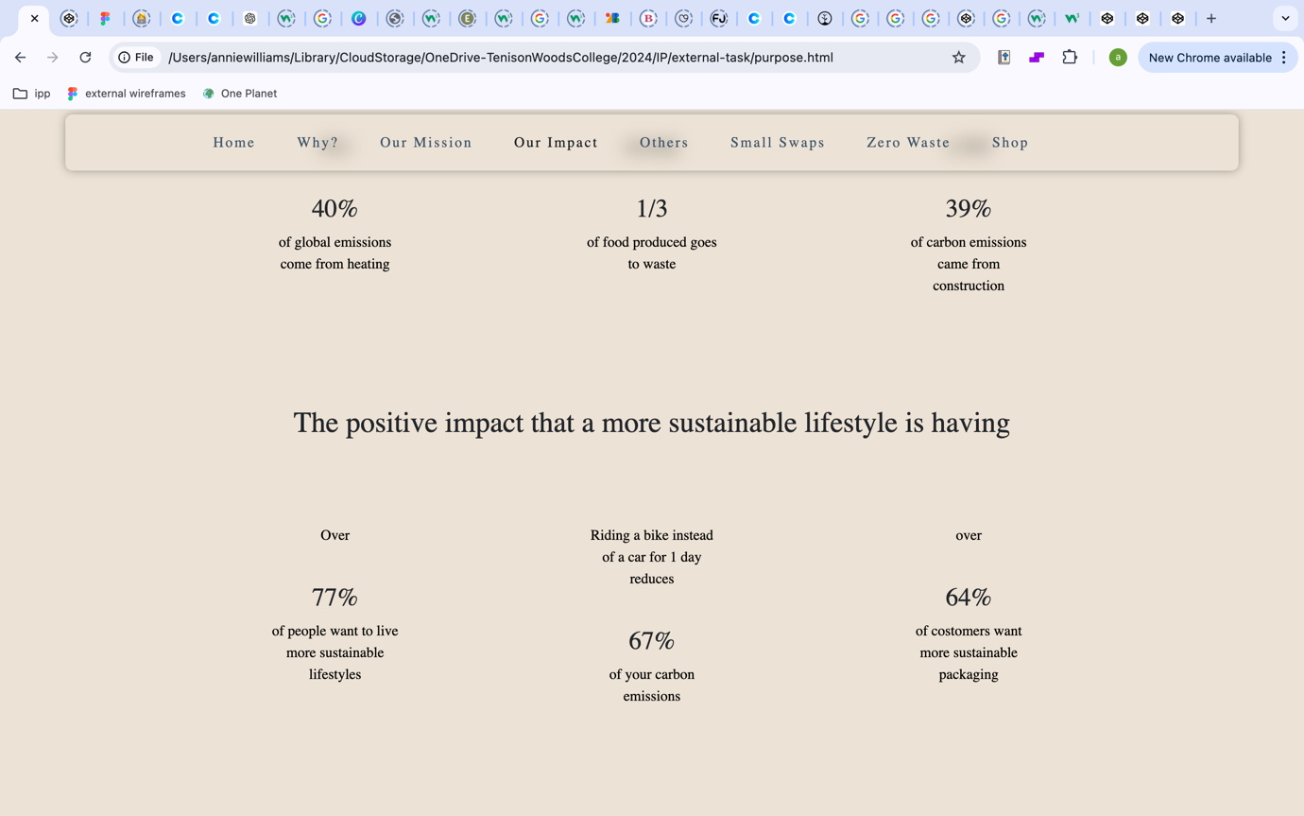

This page shows statics and the contrasting amounts of the impact living a more sustainable lifestyle has. Displaying the statistics in a way that is easy to read and eye catching. To improve this page from the first draft, more text should be added to create more understanding as the what the statistics are about and overall make it more presentable.

Design techniques:

* Emphasis
* Contrast
* Hierarchy

Page 5 – Others

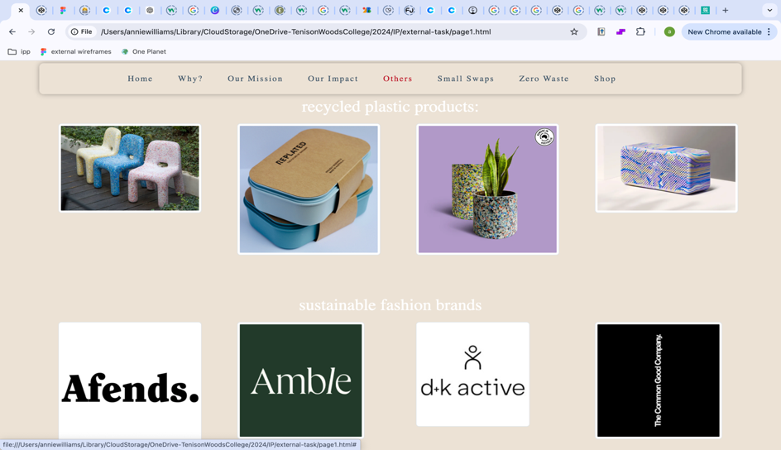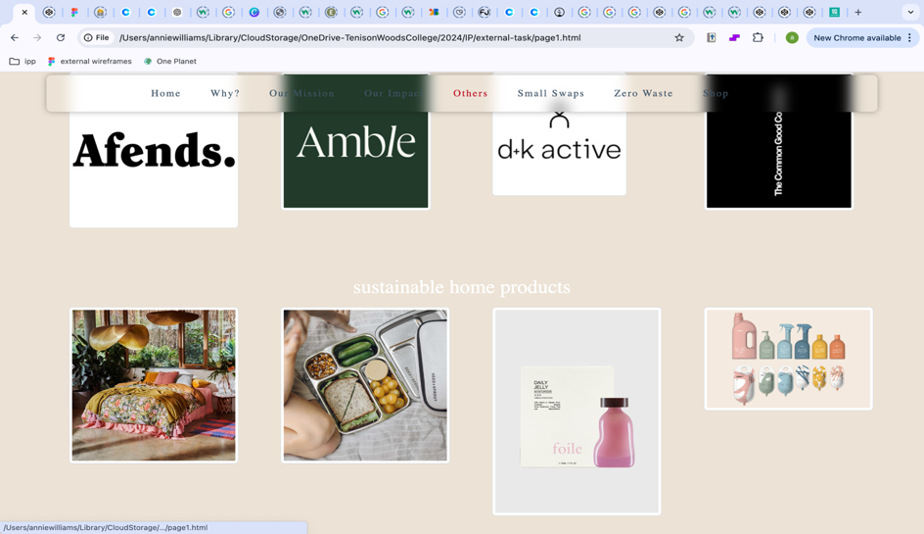

This shows other brands and companies doing similar missions to the company created ‘one planet’. Showing other missions to helping people live a more sustainable lifestyle. The page was aimed to showcase these other brands through images that link to the shop page.

Design principles:

* Repetition
* Variety
  + Through image choice

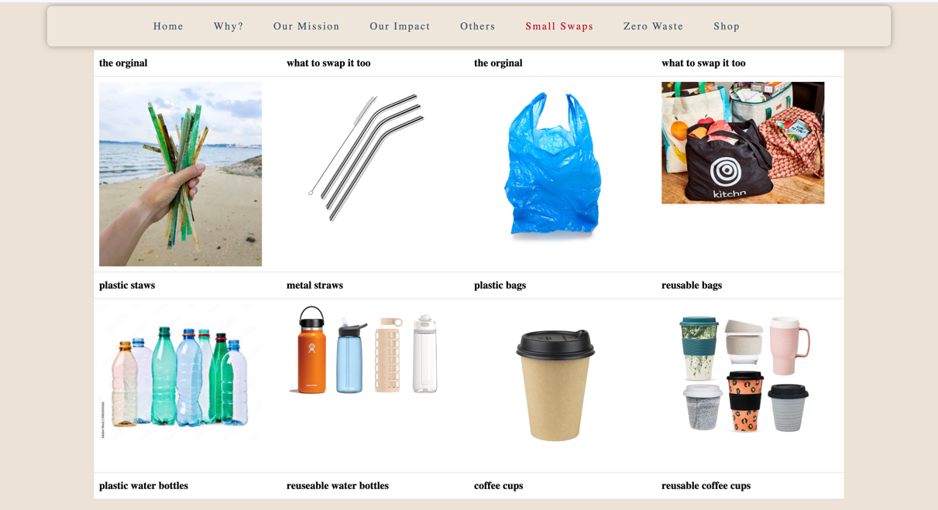Page 6 – Small Swaps

This page uses a bootstrap table to display old products and a more sustainable options side by side.

The first draft showcases this affectively but there are some changes to be made such as the table should be the same colour as the background.

Design principles:

* Balance
* Repetition
* Rhythm

Page 7 – Zero Waste

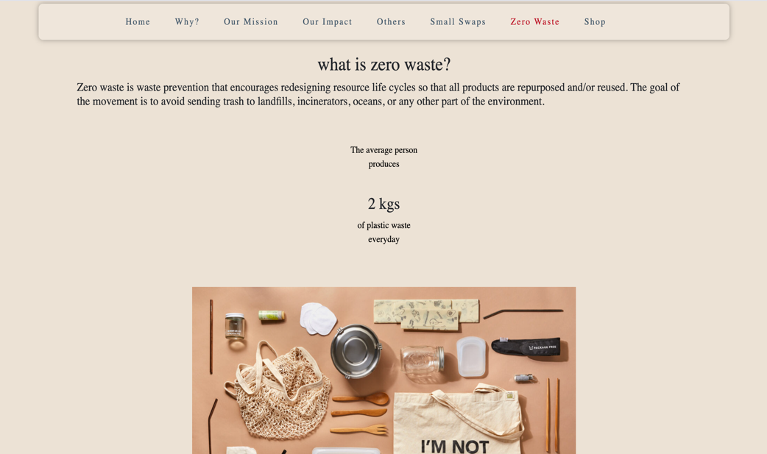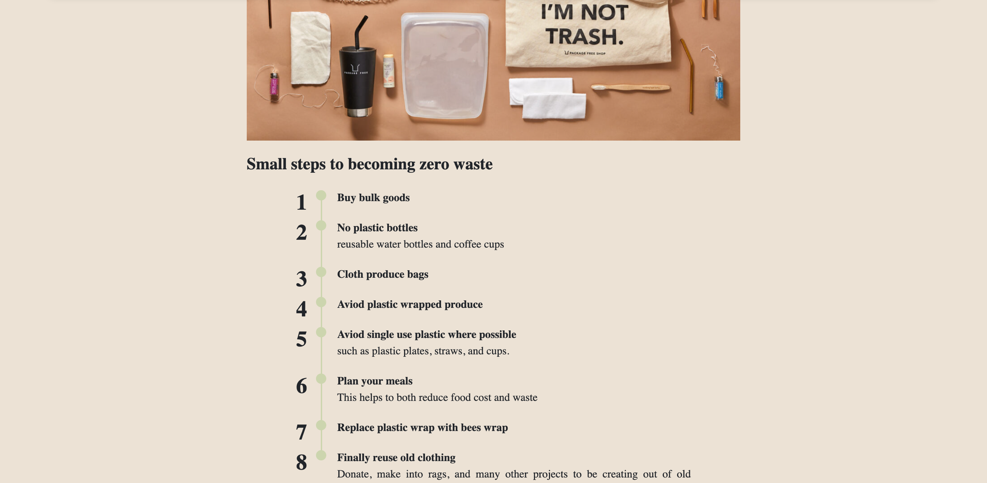

This details a zero-waste lifestyle, using a combination of different presentations such as lists, images, and body texts. The page is very similar to the wireframe and depicts all the information it should.

Design principles:

* White space
* Hierarchy
* emphasis

Page 8 – Shop

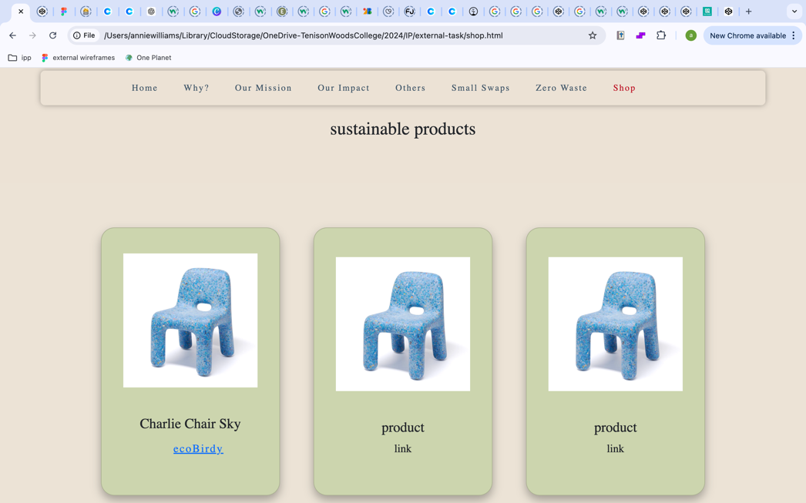A shop page using bootstrap card to show the products and stuff detailed on other pages.

The cards where orginally in green with and did not show the content in a way that matched the rest of the website. They also didn’t look like show cards as the links were text.

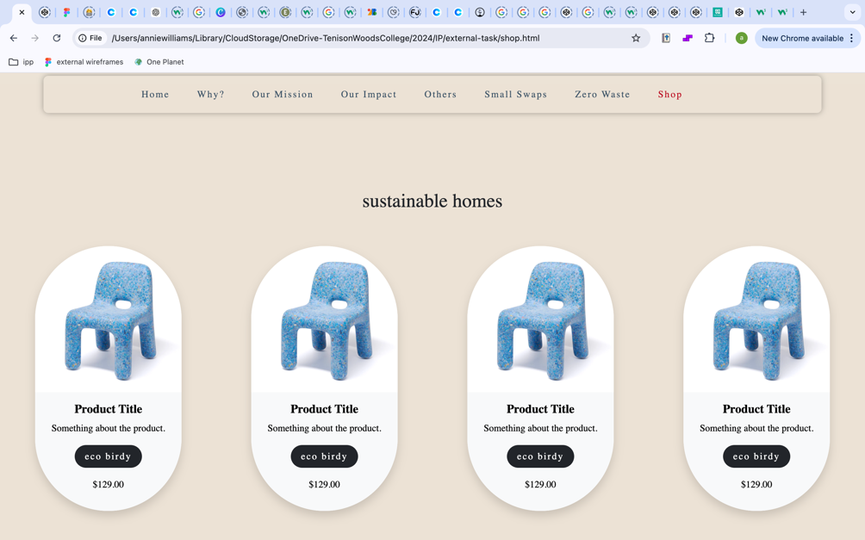

The new bootstrap cards were better presented and created better unity within the design as the images fitted better within the cards.

Design principles:

- unity

- consistency

- contrast

*Word dump*

*Why?*

**Why are sustainable lifestyles important?**

**What is a sustainable lifestyle?**

a sustainable lifestyle is a choice to minimize your enviromental impact, this includes: Conservation of Resources: Use energy and water efficiently. This includes things like turning off lights when not in use, reducing water waste, and using energy-efficient appliances. Reduced Waste: Minimize waste by recycling, composting, and reducing single-use plastics. Opt for products with minimal packaging and avoid disposable items. Sustainable Transportation: Reduce your carbon footprint by using public transportation, carpooling, biking, or walking. If possible, consider driving a fuel-efficient or electric vehicle. Eco-friendly Products: Choose products made from sustainable materials and support companies with environmentally friendly practices. This includes buying organic or locally-produced food. Sustainable Food Choices: Incorporate more plant-based foods into your diet, as meat and dairy production typically have higher environmental impacts. Support local farmers and eat seasonally. Energy Use: Use renewable energy sources if possible, such as solar or wind power. Ensure your home is well-insulated to reduce heating and cooling needs. Conservation and Protection: Support conservation efforts and be mindful of your impact on local ecosystems. This can involve activities like participating in clean-ups or supporting wildlife protection initiatives. Mindful Consumption: Be conscious of your consumption patterns and aim to buy only what you need. Prioritize quality over quantity and consider the lifecycle of the products you buy.

**Our impact on the enviroment**

Humans have had a profound impact on the environment, both positive and negative. Industrialization and technological advancement have led to significant progress, but they have also resulted in widespread environmental degradation. Activities such as deforestation, pollution, and overexploitation of natural resources have disrupted ecosystems, led to loss of biodiversity, and contributed to climate change. The burning of fossil fuels releases greenhouse gases, leading to global warming and more extreme weather events. However, human ingenuity and awareness have also driven efforts toward sustainability, conservation, and the development of cleaner technologies. Balancing progress with environmental stewardship is crucial for ensuring a healthy planet for future generations.

*Our Mission*

**Building a sustainable lifestyle**

**One Planets mission**

Our mission is to support people to build a sustainable lifestyle. A sustainable lifestyle is one where we make conscious decisions in order to reduce our plastic consumption, our energy uses, and make choices to reduce our impact on the environment around us these choices help to reduce the impact we as humans are having on the planet and make better choices for our lifestyles. aiding in a better future for us and our planet.  
Creating a sustainable lifestyle isn't difficult.

**The positive impact of a sustainable lifestyle**

One Planets mission is to aid people in creating a more sustainable lifestyle through small changes in their everyday lives. By encouraging people to make small changes, great impacts can be made on pollution both in waterways and the atmosphere.

**These companies can be found below:**

This is done by supporting businesses and companies who are aiming to do this. There are countess businesses out there aiming to create sustainable options easier for everyone. This includes everything from homes to better food options. Not only are their companies that are producing products to make sustainable living easier but also ones working to recycle the huge amount of plastic waste generated by the globe.

**Some of these companies can be found below:**

read more on [sustainable homes](shop.html), [products](shop.html) and [recylcing companies](page1.html).

*Our impact*

**Where the most change needs to be made globally**

Over 40% of global emissions come from heating

Currently 1/3 of food produced goes to waste

in 2022 39% of carbon emissions came from construction

**The positive impact that a more sustainable lifestyle is having**

Over 77% of people want to live more sustainable lifestyles

Riding a bike instead of a car for 1 day reduces 67% of your carbon emissions

Over 64% of costomers want more sustainable packaging

*Others*

**Sustainable brands within Australia**

**Recycled plastic products:**

Australia has made significant strides in promoting the use of recycled plastic products, showcasing a commitment to sustainability and environmental responsibility. Various companies and organizations are transforming post-consumer plastics into a wide range of items, from durable outdoor furniture and playground equipment to construction materials and packaging solutions. These initiatives not only help divert waste from landfills but also reduce the demand for virgin plastics, thereby lowering carbon footprints. By prioritizing recycled materials, Australian businesses are fostering a circular economy, encouraging innovation, and inspiring consumers to embrace eco-friendly choices. This shift not only benefits the environment but also supports local economies and creates jobs in the recycling and manufacturing sectors.

**Sustainable fashion brands**

Sustainable fashion brands are revolutionizing the clothing industry by prioritizing eco-friendly practices and ethical production methods. These brands focus on reducing environmental impact by using organic, recycled, or upcycled materials, and they often emphasize transparency in their supply chains to ensure fair labor practices. From high-end labels to everyday wear, sustainable fashion encompasses a diverse range of styles and price points, making it accessible to a broader audience. Many brands also promote the concept of slow fashion, encouraging consumers to invest in timeless pieces that last longer and contribute to a circular economy. By raising awareness about the impact of fast fashion, these brands inspire a shift toward more mindful consumption, ultimately fostering a healthier planet and a more ethical industry.

**Sustainable home products**

Sustainable home products are gaining popularity as consumers increasingly prioritize eco-friendly living and environmental responsibility. These products, ranging from biodegradable cleaning supplies and organic textiles to energy-efficient appliances and furniture made from reclaimed materials, are designed to minimize ecological impact while enhancing comfort and style. Brands focus on using renewable resources, reducing waste, and promoting fair labor practices in their manufacturing processes. Additionally, many sustainable home products come with eco-certifications that assure consumers of their environmental claims. By choosing these products, homeowners not only create a healthier living space but also contribute to a broader movement towards sustainability, helping to conserve resources and reduce their carbon footprint.

*Small swaps*

**Small steps towards a sustainable lifestyle**

Creating small changes in our daily lives can significantly impact the environment, demonstrating that individual actions collectively lead to substantial benefits. Simple steps, such as reducing single-use plastics, conserving water, using energy-efficient appliances, and opting for public transportation or cycling, can lower our carbon footprint and resource consumption. Moreover, adopting habits like composting food waste and supporting local, sustainable products helps promote a circular economy and reduces landfill contributions. When more individuals commit to these small, sustainable practices, it fosters a culture of environmental awareness and responsibility, ultimately driving demand for greener alternatives and influencing larger systemic changes. This ripple effect underscores the power of personal choices in creating a healthier planet for future generations.

*Zero Waste*

**What is zero waste?**

Zero waste living is an environmentally conscious lifestyle aimed at minimizing waste and maximizing resource efficiency. This approach encourages individuals and communities to reduce their waste output to as close to zero as possible by rethinking consumption habits, prioritizing reusable products, and choosing items that are biodegradable or recyclable. This means rejecting unnecessary products, reducing overall consumption, reusing items whenever possible, recycling materials responsibly, and composting organic waste. By embracing zero waste principles, individuals not only lessen their environmental impact but also cultivate mindfulness about their consumption patterns, fostering a more sustainable lifestyle. Zero waste is waste prevention that encourages redesigning resource life cycles so that all products are repurposed and/or reused. The goal of the movement is to avoid sending trash to landfills, incinerators, oceans, or any other part of the environment.

The average person produces

2 kgs

of plastic waste everyday

**Small steps to becoming zero waste**

1. **1Buy bulk goods**
2. **2No plastic bottles**

reusable water bottles and coffee cups

1. **3Cloth produce bags**
2. **4Aviod plastic wrapped produce**
3. **5Aviod single use plastic where possible**

such as plastic plates, straws, and cups.

1. **6Plan your meals**

This helps to both reduce food cost and waste

1. **7Replace plastic wrap with bees wrap**
2. **8Finally reuse old clothing**

Donate, make into rags, and many other projects to be creating out of old clothing.

*Shop*

**1.18L Hydro flask**

The bottles are dishwasher safe and the water stays cold for 24 hours, and hot for 12.

**Stainless Steel Straws**

Made from high-quality, food-grade Stainless Steel #304. They never leach taste, and feature an 8mm wide diameter.

**Mesh produce bag**

The cotton mesh produce bags come in assorted sizes for separating out all kinds of fruit and veg.

**340ml keep cup**

Drafted cup for perfect pour. Drink lid on or off. Press on splashproof sipper lid. Enjoy the look and taste.

**Charlie Chair**

The Charlie Chair is designed for kids. With its rounded edges, Charlie is safe and comfortable for everyone.

**Duo reusable mealboxes**

The perfect takeaway meal boxes made from recycled Certified Ocean Bound Plastic. Food safe and BPA free.

**Recycled Riser**

One of a kind piece manufactured from 100% recycled HDPE - household packaging waste.

**Gomi Speaker**

Handmade UK-made Bluetooth speaker made from recycled plastic, available in a wide varity of colours.

**Passive Home Designer**

Enduro Builders, design and create passive homes within Adeliade

**Booken Blend**

Sustainable and passive design workshops located in Australia.

**Aura Home**

The linen bedding is thoughtfully produced, focusing on sustainability and durability.

**Zero Co**

Plant-based and planet friendly cleaning and home products.

Word count: 1550

*Final product*

Annotations of final products

The final product created is a 8 page website consisting of a home page, information pages, and a shop.

*Evaluation*

Limitations within some aspects of the design due to the software chosen.

*Surveys*

*Bibliography*